Note

In this lab, we'll setup 1 master and 2 slaves on EC2 Ubuntu.

Then, we're going to run two jobs on Jenkins master and see how the loads are distributed across server/slave nodes.

Create instances

We need to create 3 instances: one for master and two for slave nodes:

NumberOfInstances3.png

The Security Group looks like this:

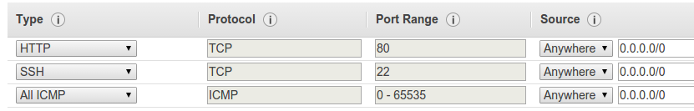

Here are our nodes just created:

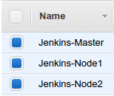

SSH key : copy master's public key to slave nodes

To enable talks between our master and slave nodes, we need to to public key (**id_rsa.pub**) of the master into slave's **authorized_keys**.

First, generate the key on Master node (xx:xx:xx:xx):

$ sudo su jenkins -s /bin/bash

$ssh-keygen -t rsa

We need to copy master's **/var/lib/jenkins/.ssh/id_rsa.pub** and put it into our slave nodes' **authorized_keys**.

So, on the slave node 1, issue the following command:

**From the target slave node's console**

1. Switch to the “root” user.

# sudo su

1. Add a jenkins user with the home “/var/lib/jenkins”. {Note : I am keeping my home directory in /var/lib/jenkins} :

# useradd -d /var/lib/jenkins jenkins

**From the Jenkins Master**

1. Copy the id_rsa.pub key from the **Jenkins** user on the master.

# cat /var/lib/jenkins/.ssh/id_rsa.pub

**From the target slave node's console**

1. Create an authorized_keys file for the Jenkins user.

# mkdir /var/lib/jenkins/.ssh

# vi /var/lib/jenkins/.ssh/authorized_keys

1. Paste the key from the Jenkins master into the file vim. Save with “:wq!”.

Do the same on slave node 2.

Jenkins install on the master server

Ref: [Installing Jenkins on Ubuntu](https://wiki.jenkins-ci.org/display/JENKINS/Installing+Jenkins+on+Ubuntu).

$ wget -q -O - https://jenkins-ci.org/debian/jenkins-ci.org.key | sudo apt-key add -

$ sudo sh -c 'echo deb http://pkg.jenkins-ci.org/debian-stable binary/ > /etc/apt/sources.list.d/jenkins.list'

$ sudo apt-get update

$ sudo apt-get upgrade

$ sudo apt-get install jenkins

Run Jenkins:

$ sudo service jenkins start

Install jre on slave nodes

SSH into slave nodes, upgrade the packages, and install a Java Runtime Environment:

$ sudo apt-get update

$ sudo apt-get upgrade

$ sudo apt-get install default-jre

That's the only package Jenkins needs for slaves by default.

In case you are having a Red Hat Machine as slaves, Install Java8 JDK

Go to Manage Jenkins --- Manage Nodes and Add New Node OR click on Build Executor Status

Slave node setup

Click New Node:

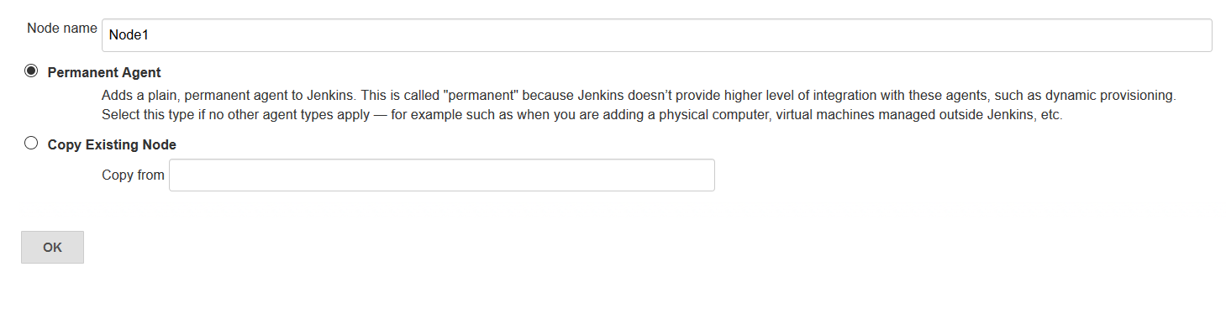

Hit OK:

Type in "Remote root directory" and make sure to use private ip of the slave host.

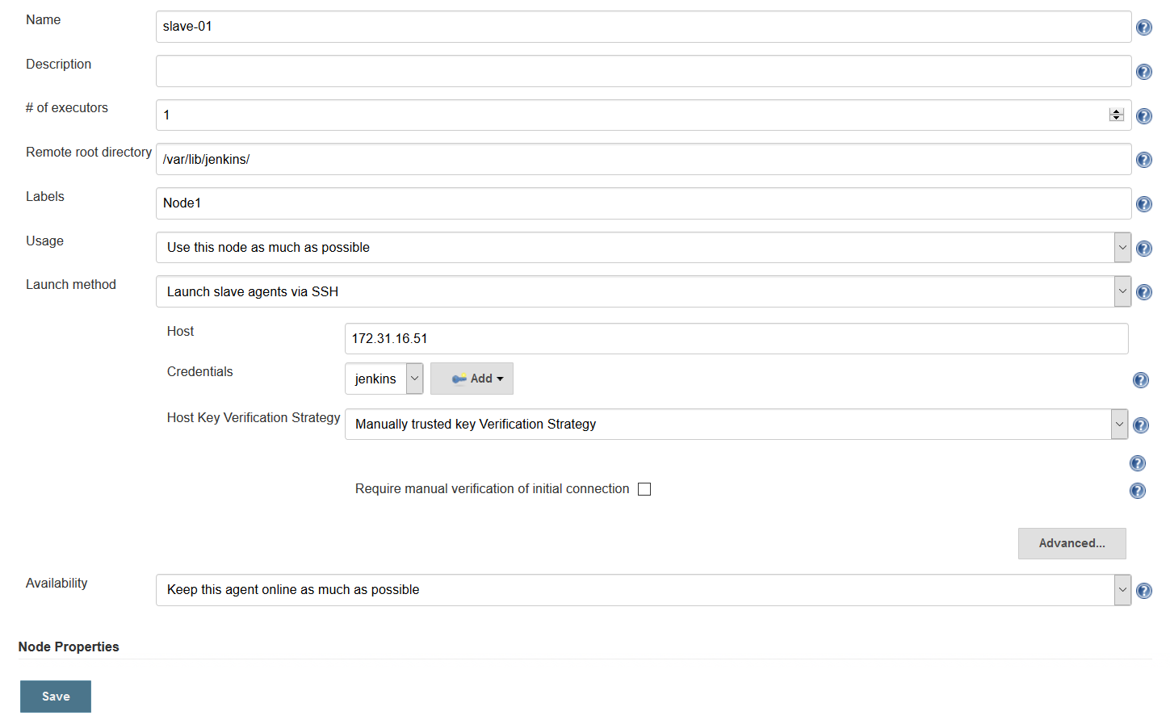

Click "Add" button on Credentials:

Type in "Username" and copy the private key (**/var/lib/jenkins/.ssh/id_rsa**) of the master server:

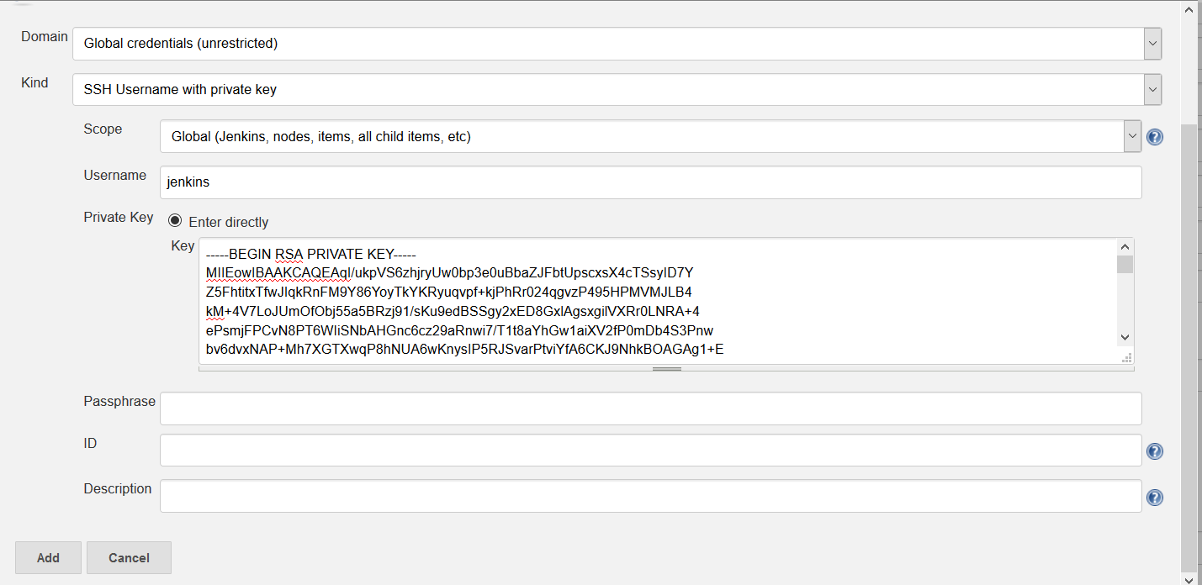

Hit "Add":

Drom drop down select the credential and Manually trusted key Verification Strategy

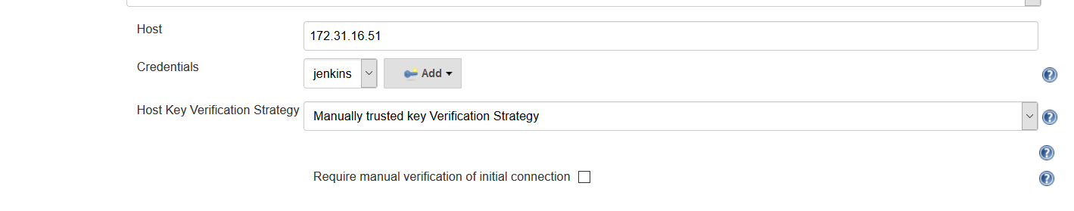

Click "Save"

Now we can see our Slave Node #1 is up and connected:

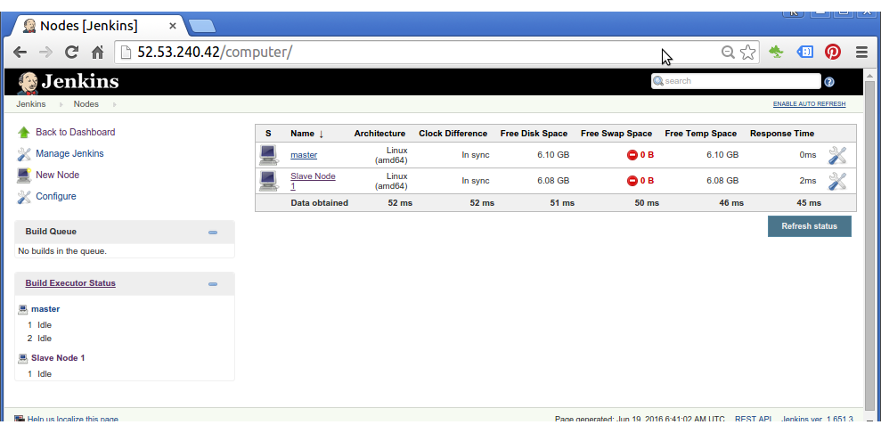

Click "Save"

Do the same to Slave Node #2. This time we'll use "Copy Existing Node":

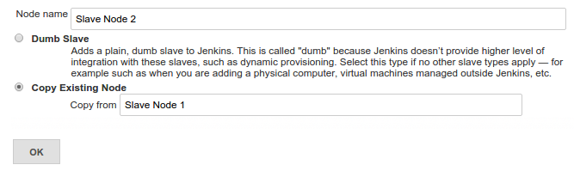

Make sure type in private ip address of Slave Node #2.

Now we have one master and two slave nodes are linked up and running:

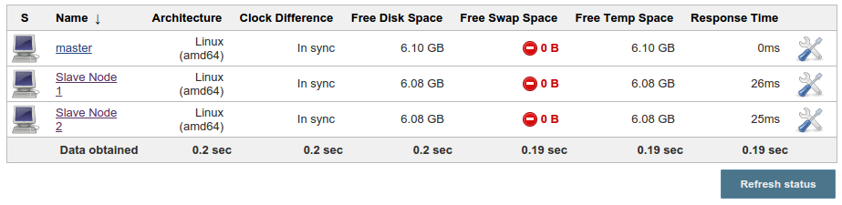

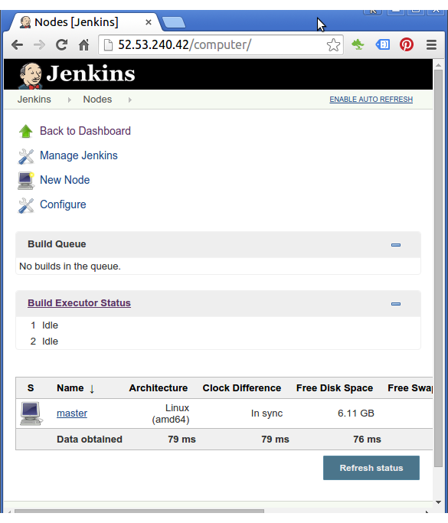

We only see the master node at this point.

Let's add new nodes for our slaves.

Running jobs

Go to Jenkins Dashboard and create two new jobs.

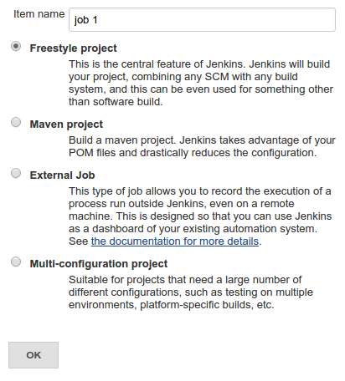

We're going to run a very simple job: sleep 30 seconds:

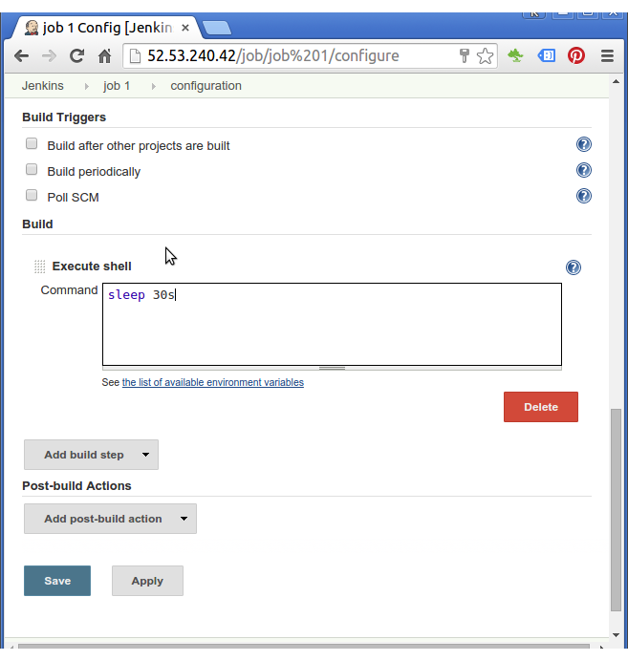

Click "Save".

Create another one for job 2 doing the same thing: sleep 30s.

Now the two jobs are running: one on master the other one on slave #2:

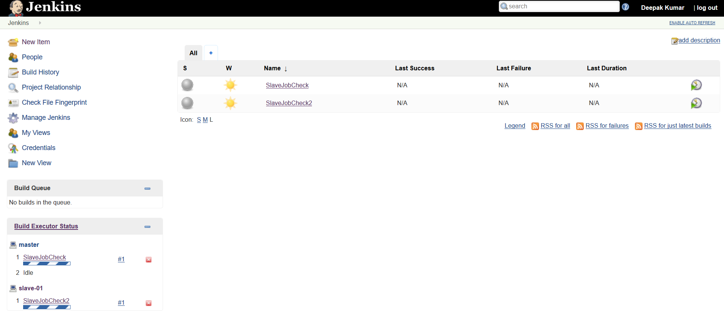

If we run 3 jobs, there will be no idling slave node.

Optional Steps to use nginx to proxy port 80-🡪8080

Setting up an Nginx Proxy for port 80 -> 8080

The Jenkins default port 8080 is not opened in our security group. So, we need to setup Nginx to proxy port 80 to 8080 so that you can keep Jenkins on 8080.

Install Nginx:

$ sudo apt-get install nginx

Remove default configuration:

$ cd /etc/nginx/sites-available

$ sudo rm default ../sites-enabled/default

Our Nginx proxy conf file (**/etc/nginx/sites-available/jenkins**) looks like this:

upstream app_server {

server 127.0.0.1:8080 fail_timeout=0;

}

server {

listen 80;

listen [::]:80 default ipv6only=on;

server_name ec2-52-53-240-42.us-west-1.compute.amazonaws.com;

location / {

proxy_set_header X-Forwarded-For $proxy_add_x_forwarded_for;

proxy_set_header Host $http_host;

proxy_redirect off;

if (!-f $request_filename) {

proxy_pass http://app_server;

break;

}

}

}

Link the configuration from sites-available to sites-enabled:

$ sudo ln -s /etc/nginx/sites-available/jenkins /etc/nginx/sites-enabled/

Then, restart Nginx:

$ sudo service nginx restart

Open up browser. Jenkins is now available on port 80: